 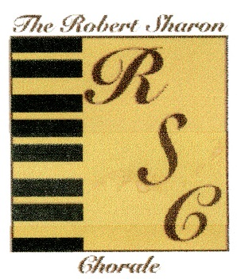 

**The Robert Sharon Chorale Presents**  
**Songs of The Season**

**Holiday Music Standards & Surprises**

Sunday, December 8, 2013 at 3 pm

The DeSantis Family Chapel, PBAU

300 Okeechobee Blvd

(Corner of Okeechobee Blvd and South Olive Avenue)  
West Palm Beach, Fl

$15.00/Adult  
$5.00 Children under 12

Purchase tickets online at:

<http://www.rschorale.com/Tickets>

or by phone at 561.687.4245

  

xx